MUN-Directors’
Booklet of
MUNOH 2017
-9th session-
04th October - 08th October

Introduction
Dear MUN-Director,
we are proud to welcome you to the ninth session of Model United Nations of Hamburg.
For all participants to have a memorable experience, we the executive team of MUNoH 2017, are keen to support all participants and help if any problems occur.
Please do not hesitate to contact us via conference-manager@munoh.de
This guide will provide some examples of Position Papers, Resolutions etc. in order to assist you in preparing your students for the conference. Furthermore, we can already present you a preliminary Program of Events, which may help you with your travel arrangements.

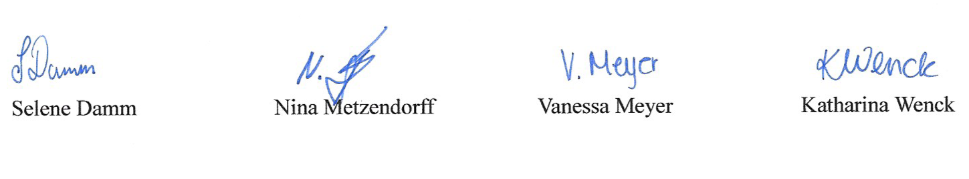
Yours sincerely,

Position | Executive team members | Contactinformation
Conference Management | Selene Damm, Nina Metzendorff, Vanessa Meyer, Katharina Wenck | conference-manager@munoh.de
Secretary Generals | Marvin Gambusch, Milena Steffen | secretary-general@munoh.de
Internal Delegate Supervisor | Lea Hansen, Virginia Pistoll | internal-delegate-supervisor@munoh.de
President of the General Assembly | Lisa Dudek | pga@munoh.de
Financial Management | Tom Luca Schleden, Max Widegreen | financial-management@munoh.de
Student Supervisors | Melissa Bauer, Jonas Dieckmann, Moritz Schnöckel | student-supervisor@munoh.de
Event Management | Aline Há, Julia Tabibi | event-management@munoh.de
Head of Secretariat | Colin Casey, Inshall Qureshi | secretariat@munoh.de
Head of Administrative Staff | Philipp Mundorf, Marko Sarić, Svea Trenkner | adminstaff@munoh.de
Head of Kitchen Staff | Kristin Albrecht, Thomas Brimm | kitchen-staff@munoh.de
Head of Computer Staff | Daniel Louizov, Rames Razaqi | computer-staff@munoh.de
Head of Media Staff | Jonas Gampe, Luca Krohn | media-staff@munoh.de
Head of Press | Eva Dickmann, Jonas Gampe, Annika Gedlek | press@munoh.de
Head of Approval Panel | Ms. Breckwoldt | breckwoldt@web.de

Structure
Introduction 1

Introduction 2
MUN-Directors’ Tasks 5
Country Distribution 5
Ambassador 5
Preparation for Delegates 6
Resolution 6
Position Paper 7
Short Summary 7
The Delegates’ Preparation 7
For the Ambassador of the Country Represented 8
Preparation for Student Officers (Chairs) 8
Research Reports 8
Lobbying and Approval Process 9
Behavior During the Conference 10
Dress Code 10
Official Language 11
Host Families 11
Sample Position Paper/Policy Statement 11
Preambulatory & Operative Clauses 14
Sample Resolution 15
Sample Ambassador Speech 17
Important Deadlines and Dates 17

MUN-Directors’ Tasks

You, as an MUN-Director, are responsible for guiding your delegates through the preparation process of the conference. Please check every delegate’s documents as well as the ambassador speeches (explained below) for the Opening Ceremony for content and grammar mistakes and give your students further ideas for improvement.
During the conference, we kindly ask for your support in the Approval Panel correcting resolutions together with the Main-Submitters. Of course you are always welcome to visit the forums and watch your delegates and chairs during debating time.
During official MUNoH evening activities we furthermore ask you to help supervise the students. You will receive an MUN-Directors’ Program of Events shortly before the conference which highlights the activities during which we require your presence.

Country Distribution

A few weeks after you have returned the Final Registration to us, you will receive your country allocation. Every student will represent a delegate of a country or Non-governmental organization (NGO) or Inter-governmental organization (IGO) in a committee, a commission or a council. When allocating your delegates, please try to avoid allocating several first-timers to the same committee.
If your school has been honored with a seat in the Security Council, please make sure you choose an experienced and dedicated student for this position, as the form of debate in the Security Council is more complex than in the other forums.

Ambassador

Every delegation is led by an ambassador who has to deliver a speech at the Opening Ceremony on Wednesday. In this speech he/she has to first of all address the house and then state or comment on the most important issues of the conference for his or her country, NGO or IGO in English. Comments on current political affairs from his or her country’s point of view are of course also possible. However, the length of the speech must not exceed one minute.
Additionally, the ambassador might be called upon by the Security Council to deliver a speech and answer questions on current affairs in his/her country, if the ambassador’s country is involved in an issue debated in the Security Council. The same goes for committees or commissions, although this is a rare occasion. If such a speech is necessary we will send around reminders, but we also kindly ask the ambassadors to check beforehand whether their country is involved in certain issues.
Thus when choosing an ambassador it is helpful to pick a student who feels confident speaking in front of an audience and who is willing to put a bit more work into preparing for the conference. Please remember that Security Council delegates cannot take on the role of ambassadors.

Preparation for Delegates

When assisting your delegates in their preparation process, please tell them to read the Research Reports written by the chairs. They can be found on our website at “MUNOH 2017” ➔ “Issues on the Agenda”. (www.munoh.de)
The Research Reports contain basic information about the topic and further helpful links in order to simplify the delegates’ research.
Furthermore, the delegates should inform themselves about the current opinion of the country they represent concerning the issues debated in their commission, committee or council.
The research will then help them to write one Resolution and either two or three Position Papers on the issues debated in their forum. All papers have to be written in the official language, English. We consider this kind of preparation mandatory in the interest of the debates during the conference.
Security Council members are excluded from this rule, they only have to write Position Papers to every issue and prepare Operative Clauses for every topic discussed.
We kindly ask you to correct the Position Papers and Resolutions regarding language and content prior to the conference. Your delegates are expected to send their work (at least one resolution, two/three position papers) to their chairs by 10th September 2017.
In case of non-compliance the delegate will be excluded from lobbying and has to finish the Resolution and Position Papers before he/she can join the normal procedure of the conference.

To simplify lobbying all the delegates’ documents should have the following layout:

Font style: Times New Roman
Font size: 12
Line pitch: 1.5 lines

Resolution

A resolution basically consists of perambulatory clauses (PC), which state the problem of the issue and operative clauses (OC) which contain possible solutions to the topic discussed. The operative clauses suggest several measures in order to solve the issue. The delegates should keep in mind that the solutions need to be realistic and consistent with their countries’ policies, since it is a simulation of the United Nations.
In this booklet, you will find a sample resolution in the correct form concerning layout and the use of phrases. There is a limited list of verbs that can start a PC and an OC. Please consider them as well as the layout rules when correcting the draft resolutions. This will also be one of your tasks during your work in the Approval Panel.

Position Paper

At the beginning of the Position Paper, there is a brief summary of the issue, followed by measures taken by the country and the UN. It is also important to mention the country’s position on the UN measures, possible solutions the country suggests and the country’s opinion regarding the issue as a whole.
Please also check the Position Paper regarding language and content.

Position Papers are important not only for the delegate’s personal preparation but also in order to give the chairs as well as other countries an insight into other countries’ opinions regarding the issues. Therefore, we expect every delegate to write Position Papers on all topics discussed in the committee, commission or council, except for one, for which the delegate prepares a Resolution instead.

Short Summary

The Delegates’ Preparation

- Read Research Report
- Inform themselves about country’s opinion
- Write a Resolution and Position Papers (consists of operative clauses and perambulatory clauses) ➔list is at the end of this document
➔All documents need to be written in English.

Position Paper

- Summary of issue
- Country’s opinion ➔ measures taken
- Possible and realistic solution in accordance with country’s opinion

Resolution

- Read Research Report
- Short summary (preambulatory clauses)
- Possible solutions (operative clauses)

For the Ambassador of the Country Represented

Ambassador’s Speech at the Opening Ceremony

- Address the house e.g. Conference Manager, Secretary Generals and President of the General Assembly etc.
- Mention important topics for delegation
- Yield the floor back to the PGA at the end of the speech
- Time limit: one minute

Preparation for Student Officers (Chairs)

The student officers or chairs are the heads of the forums. Before the conference they write Research Reports, which are to guide the delegates in their research. The student officers also correct position papers the delegates send in prior to the conference, since they have a very good knowledge of the issues after having written the Research Report.
During the conference they are in charge of the lobbying process as well as debates in their forum. They decide on who has the floor and solve conflicts or misunderstandings between delegates during the debate. Furthermore, they read the amendments and have to know all motions and points by heart.

Research Reports

The Research Reports provide a general overview of the Issue and offer a first introduction into the delegates’ research. A Research Report follows a certain outline:

1) Mention the email address we gave you
2) Description of the issue
3) Background information
4) Historical background
5) Glossary
6) How to prepare as a delegate
7) UN resolutions regarding the issue
8) Useful links
9) Sources

A sample research report is available online on our website at "munoh.de" sectioned sample papers. Link: http://www.munoh.de/downloads/Sample_Research_Report.pdf

Lobbying and Approval Process

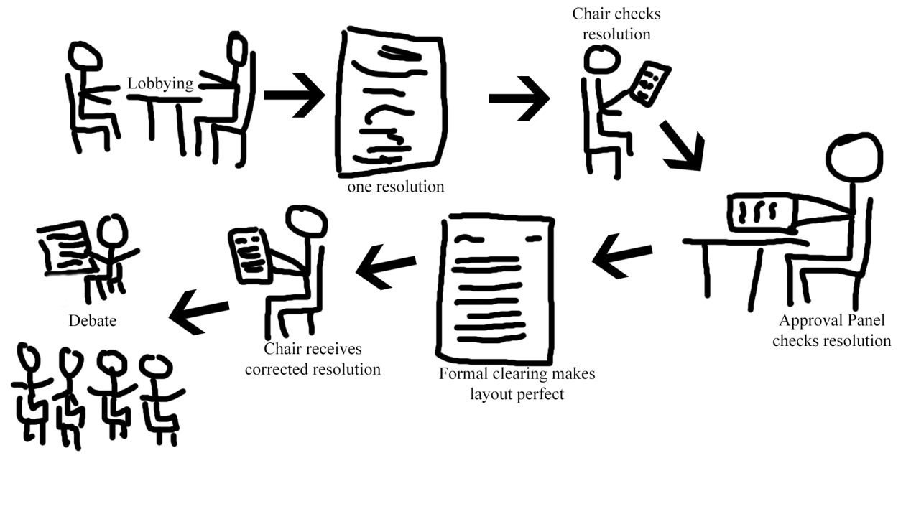
Since every delegate should have written a resolution on one topic, they will form groups in their forum with other delegates willing to discuss the same topic. During lobbying time the group will create a new resolution, which then needs to be corrected by firstly the chairs, afterwards by the Approval Panel and by the Formal Clearing Office (FCO) and finally the chairs again.To ensure the process of correction we will implement the Approval Sheet which has to be signed by every named forum. The resolution is therefore only allowed to be debated on if it first passes the chairs, then the Approval Panel, afterwards the Formal Clearing Office and finally the chairs again. However, beforehand, the group needs to decide on one main-submitter, the country which can present the Resolution best to the forum, and 5 co-submitters who either support the resolution or are interested in debating it.

Behavior During the Conference

Dress Code

The way the participants are dressed has a huge impact on the feeling during MUN. However, there are always problems with delegates not dressing in line with the dress code. In order to reduce the number of people punished for dressing inappropriately, we will explain our conference’s dress code:
The male delegates and chairs have to wear a shirt and a blazer or suit jacket. Also a tie or a bow tie has to be added to the outfit. Your trousers should either be suit trousers or other business styled trousers, such as Chinos. Casual trousers such as jeans are not in order. The shoes should be formal and not include trainers, boots or open shoes.
Apart from bow tie and tie, the female delegates and chairs can of course dress up like their male colleagues. Further they are allowed to wear blouses or dresses.
Every female participant has to wear a closeable blazer with at least one button. In combination with blouses and shirts you can wear a skirt or suit trousers. When wearing a skirt, you are required to wear tights, the same goes for a dress combination .
Casual trousers such as jeans or leggings are prohibited. For shoes, we will only allow formal looking shoes (no peeptoes or sandals). As you will walk in those shoes for several days, we warmly recommend shoes without high (sky) heels. You can further add some jewelry to your dress.
In general, colors included in your outfit should be neutral and subdued. In session and during formal debate, suit jackets and blazers have to be worn, unless the chairs/presidents have decided differently. In case a delegate rises for whatever reason, his/her blazer button must be closed, but opened again when the delegate takes his/her seat. Ladies wearing skirts or dresses should make sure that no more than a palm of a hand fits between the edge and the top of their knee. They should further take into account that the most important look is your overall look; therefore make sure that all your pieces fit together properly.
In the spirit of the conference, we kindly ask the MUN-Director to adhere to the dress code by setting a good example.

Official Language

The official language during the whole conference is English. All documents such as Position Papers have to be written in English. All delegates, MUN-Directors, Chairs and Presidents, Administrative Staff and Executive Team have to stick to the official language during the conference and at the social events. Notepapers also have to be written in English and will be checked by the Administrative Staff. In case of non-compliance the notepaper will be given to the Chairs who can choose an adequate punishment.

Host Families

If your students are staying in host families, please remind them of the rules they had to sign. It is not always easy to find enough host families for the conference, so both you and we as the organization team rely on the good behavior of your students during their stay, so that the host families feel motivated to house guests again during next year’s conference.

Sample Position Paper/Policy Statement

United Kingdom Security Council, Fabian Krusa
The Situation in Afghanistan
The second issue before the SC can be considered the most important topic regarding international peace and security of the past 12 years: The situation in Afghanistan. The country, located in the Middle East, and home of 21.8 million people has been the topic of discussion for the General Assembly and the Security Council for several times, especially since the start of the International Security Assistance Force (ISAF) mission after the 9/11 attacks.
Though having been a very prosperous hub of an international trade route one day, the past 34 years of war have let Afghanistan become one of the poorest countries in our world. Today a third of the Afghans have less than sixty pence a day and one in 6 children die before they are five years old.
Moreover, the life expectancy is only 44 in average, which is really low compared to around 80 in the UK.
Additionally, there is still a large number of an-alphabets and what must not be underestimated, there is still discrimination and violation of women's rights and their equality in Afghanistan although some efforts in the past decade. The origin of all these humanitarian, financial as well as social problems dates back to the year 1978 when the Afghan Civil War began after the former General Daud had been overthrown and killed, leading to a seizure of power by the Peoples Democratic Party of Afghanistan (PDPA). In the following year the Soviet intervention, intending to aid the PDPA, took place. This however, was directly opposed by the mujahideen, an Afghan resistance force, which was supported by mainly the US but also China and Pakistan as well as Iran. The consequence of this conflict was a civil war of a disastrous extent.
In that time already the General Assembly first dealt with the Afghan issue and adopted resolutions 462 as well as 35/37. In A/RES/35/37 the GA stresses the importance of the sovereignty of the Afghan people and further calls up the international forces to withdraw while still calling for international humanitarian assistance.
After ten years the Red Army had to quit but civil war continued though. The following decade was dominated by several civil uprisings and fights between different groups of which one is the Taliban. After having failed in Kabul in 1995 they finally took over control in the “Islamic Emirate of Afghanistan” in 1996. Other states such as the US and Russia supported a resistance group agianst them, since the Taliban gave safe heaven to the Al-Qaeda to plan and carry out their terrorist attacks all over the world, culminating in the 9/11 attacks.
After that the Taliban refused to bring the leaders of Al-Qaeda to account and therefore the international community, meaning the NATO as well as the USA, UK and France in cooperation with the Northern Alliance, had to intervene militarily in order to “protect the international security by helping the Afghans to take control of their own” as the British First Secretary of State, William Hague, stressed in a report last December.
The decision of the UNSC to establish the ISAF(International Security Assistance Force) has to be considered a very important step and was warmly welcomed by the UK. The United Kingdom has from the beginning on supported the ISAF mission with thousands of soldiers, having 9,500 of them stationed in Afghanistan, mainly in the Southern province of Helmand, today.
The second relevant step was the establishment of the UNAMA (United Nations Mission in Afghanistan) by the SC in 2002 with S/RES/1401 which the UK also voted in favor for. The UNAMA shall assist the process of transition in Afghanistan and lay the foundations for peace and security. The UK considers the work of this mission as effective and therefore also voted in favor of S/RES/2041 which last year extended the mandate of the UNAMA for another year.
More than a decade of foreign intervention in the country has passed and the mission is coming to an end. The troops of the ISAF mission shall leave the land by the end of 2014.Though we have achieved some successes we have also seen that it is not easy or nearly impossible to totally eliminate the Taliban and Al-Qaeda. The fights between the international forces and the terrorists as well as their attacks have caused a lot of casualities ending up with a horrifying number of 3 million people killed in the country since 1978 and still a lot of humanitarian problems as aforementioned.

The United Kingdom of Great Britain and Northern Ireland considers Afghanistan the “top foreign policy priority” and our defence main effort.
We are in Afghanistan because we see our national security threatened by terrorist groups such as Al-Qaeda. The aim of the UK's intervention was to protect the national and international security by assisting the Afghans to protect their country from a return of the terrorists. To achieve that, the United Kingdom runs several projects in the middle-east state.
On the one hand the UK actively participates in the military support for Afghanistan with the soldiers sent to the ISAF mission. We are convinced that the training and extension of the Afghan soldiers as well as the national police to a level at which they can take over the control in their country has to be our goal until the end of 2014. This training of the so-called ANSF(Afghan National Security Forces), made up by the Afghan National Army (ANA), the Afghan Air Force as well as the Afghan National Police (ANP), is crucial to establish long-term security in the country. The UK, for example, has sent several British police officers to Afghanistan to mentor and train the local officers. British Defence Secretary, Phillip Hammond, as well as the Chief of Defence Staff, General Sir Richards, are convinced that the ANSF has greatly improved in the recent years and welcome the growth of their capacity to today 352,000.
Consequently the UK wants to withdraw its troops step by step until the end of 2014 in the stipulated transition process. By the end of 2013 the British soldiers will have a number of 5,200 as agreed at the Lisbon Summit in 2006. Till that date British soldiers will, albeit with a lower capacity, continue their work aside the Afghan forces.
Moreover, the UK emphasizes that it will fulfill its commitment to continue the cooperation beyond 2014 in the way of building up the government as well as training the ANSF forces.
Welcoming the statement to the SC of H.E Ambassador Stephan Evans, the NATO Assistant Secretary General at the SC, in which he notices a success of the mission and concludes that the transition process can be achieved in time, the UK is convinced of that as well and wants to work with greatest effort to reach this goal.

Preambulatory & Operative Clauses

Our Preambulatory Clauses
Acknowledging  Affirming  Alarmed by  Approving  Aware of  Believing  Bearing in mind  Cognizant of Concerned  Confident  Contemplating  Convinced Conscious | Declaring  Deeply (…) Deploring  Disturbed  Emphasizing Expecting  Expressing  Fulfilling  Fully (…)  Further (…)  Guided by  Having (…) Hoping | Keeping in mind  Noting (…)  Observing Reaffirming  Realizing  Recalling  Recognizing Regretting  Referring  Seeking  Taking (…)  Viewing with appreciation  Welcoming

Our Operative Clauses
Accepts  (Re-)Affirms  Approves  Authorizes*  Calls  Calls upon  Condemns* Confirms  Congratulates  Considers  Decides* | Declares Demands*  Deplores Designates  Draws attention  Emphasizes  Encourages  Endorses  Expresses (…)  Further (…)  Invites | Proclaims  Recommends Regrets Reminds  Requests  Solemnly affirms  Strongly (…)  Supports Transmits  Trusts Urges

*Can only be used by the Security Council

Sample Resolution

FORUM: First committee
QUESTION OF: Effective international arrangements to assure non-nuclear-weapon states against the use or threat of use of nuclear weapons
SUBMITTER: Seychelles
CO-SUBMITTER: Germany, Guatemala, Peru, South Africa, Sweden, Turkey

(01) FIRST COMMITTEE OF THE GENERAL ASSEMBLY,

(02) Deeply concerned about the rising number of nuclear-weapon states,

(03) Calling to mind that more nuclear players reduce security for all, multiplying the risks of
(04) miscalculations, accidents or unauthorized use,

(05) Observing that the availability of civil nuclear programs increases the risk of military
(06) use,

(07) Keeping in mind that political instability, especially in the Middle East, is the main
(08) reason for non-nuclear-weapon states to manufacture nuclear weapons,

(09) Calling to mind that the proliferation of nuclear weapons is a global problem thus
(10) international arrangements have to be found,

(11) Fully aware that the Treaty on the Non-Proliferation of Nuclear Weapons is not effective
(12) enough to assure non-weapon states against the use or threat of use of nuclear weapons,

(13) 1. Calls upon all nuclear weapon states to start a disarmament program in order to:
(14) a) decrease inequality,
(15) b) promote global security;

(16) 2. Hopes for the expansion of the Comprehensive Nuclear Test Ban Treaty
(17) Organization (CNTBTO) in order to:
(18) a) Take on the inspection and controlling tasks which the IAEA now
(19) fulfils,
(20) b) Ultimately subsume the IAEA into this organization;

(21) 3. Reminds the commission of the importance of tightening export controls;

(22) 4. Further reminds all members that inspectors need more powers due to the fact that (23) many states fear controls, which could be reached by:
(24) a) Giving the inspectors the right to visit concerned nations whenever
(25) they want,
(26) b) Ensuring that the results of inspections will be published in order to:
(27) i. Establish an early warning system,
(28) ii. Find measures to prevent the extension of nuclear
(29) weapons.

Sample Ambassador Speech

Honorable President of the General Assembly,
Dear Secretary Generals,
Hard-working Conference Managers,
Esteemed executive staff,
Lovely chairs and presidents,
Distinguished MUN Directors,
Fellow delegates,
Appreciated ad-staff,
and guests,
the Grand Duchy of Luxembourg is really grateful to be at the MUNoH conference. We are very proud to be one of the five countries that have been elected into the Security Council in the elections 2012. It is the first time in history that we were given a seat and feel honored about that. Our delegates are looking forward to discussing for example the situation in Korea and especially Syria, where we are very concerned about the actions the Security Council took.
Russia and China used and still use their Veto-power to stop every good resolution which could help solve the problem. We hope that these countries will change their opinion and try to support the Security Council in finding a solution.
Furthermore, we are looking forward to our delegate in the 6th committee to push through effective changes to reform the Security Council.
We hope for interesting debates and wish everyone involved a great conference.
Thank you for your attention.
The delegate yields the floor to the President of the General Assembly.

Important Deadlines and Dates

7th-8th April: Chair Workshop at Gymnasium Meiendorf
15th May: Beginning of Online Registration
01st June: Conference Fee due
19th June: Research Reports due
10th September: Time Freeze
11th September: Position Papers and Resolution due
20th September: Time Freeze SC
08th October: Opening Ceremony
Preliminary Program of Events

Wednesday, 4th October
9.00 am - 14:30 pm | Registration | To be announced
3.00pm – 5.30 pm | City Tour | U Rathaus  (start and end of the tour)
6.00 pm - 8.30 pm | Opening Ceremony | Hamburger Rathaus  Rathausmarkt 1,  20095 Hamburg
8.30 pm – 8.45 pm | Delegates meet Chairs and afterwards MUN-Directors | Hamburger Rathaus  Rathausmarkt 1,  20095 Hamburg
Thursday, 5th October
8.30 am - 9.00 pm | Chair/Ad-staff briefing | To be announced
9.00 am - 5.00 pm | Lobbying/ SC in session | Gymnasium Meiendorf
12.00 pm - 2.15 pm | Lunch available | Cafeteria
5.00 pm – 5.30 pm | Chair/Ad-staff debriefing | To be announced
8.00 pm - 0.00 am | Official MUN Party | Club Riff  Kattjahren 1,  22359 HH
Friday, 6thOctober
9.00 am - 9.30 am | Chair/Ad-staff briefing | To be announced
9.30 am - 5.00 pm | All forums in session | Gymnasium Meiendorf
12.00 pm - 2.15 pm | Lunch available | Cafeteria
5.00 pm – 5.30 pm | Chair/Ad-staff debriefing | To be announced
7.00 pm - 10.00 pm | Committee Evening | Meeting point  U Berne  (start and end)
Saturday, 7th October
8.30 am – 9.00 am | Chair/Ad-staff briefing | To be announced
9.00 am – 2.00 pm | All forums in session | Gymnasium Meiendorf
11.45 am - 1.15 pm | Lunch available | Cafeteria
2.00 pm - 5.00 pm | General Assembly /  Councils and commissions in session | Gymnasium Meiendorf
6.30 pm – 8.30 pm | Evening at school  (with music & sncacks) | Gymnasium Meiendorf
Sunday, 8th October
9.00 am - 1.00 pm | Councils and commissions in session | Steigenberger Hotel  Heiligengeistbrücke 4,  20459 HH
9.00 am – 1.00 pm | General Assembly in session | Steigenberger Hotel  Heiligengeistbrücke 4,  20459 HH
1.00pm - 2.00pm | Lunchbreak | Outside the Steigenberger Hotel
2.00 pm - 3.30 pm | Closing Ceremony | Steigenberger Hotel  Heiligengeistbrücke 4,  20459 HH

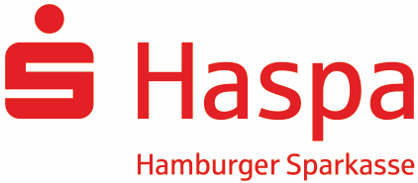
Our Sponsors:

